Project Design Phase-II
Technology Stack (Architecture & Stack)

Date | July 9 2026
Team ID | SWTID-2026-2791
Project Name | OptiCrop: Smart Agricultural Production Optimization Engine
Maximum Marks | 4 Marks

Technical Architecture:
The OptiCrop system helps farmers make informed crop selection decisions by analyzing soil parameters, weather conditions, and historical agricultural data. The system uses a Machine Learning model to recommend the most suitable crop, estimate yield, and improve agricultural productivity. It integrates a web-based user interface, backend processing, database storage, external weather services, and prediction models to deliver accurate recommendations.
References:Flask Documentation https://flask.palletsprojects.com/⁠
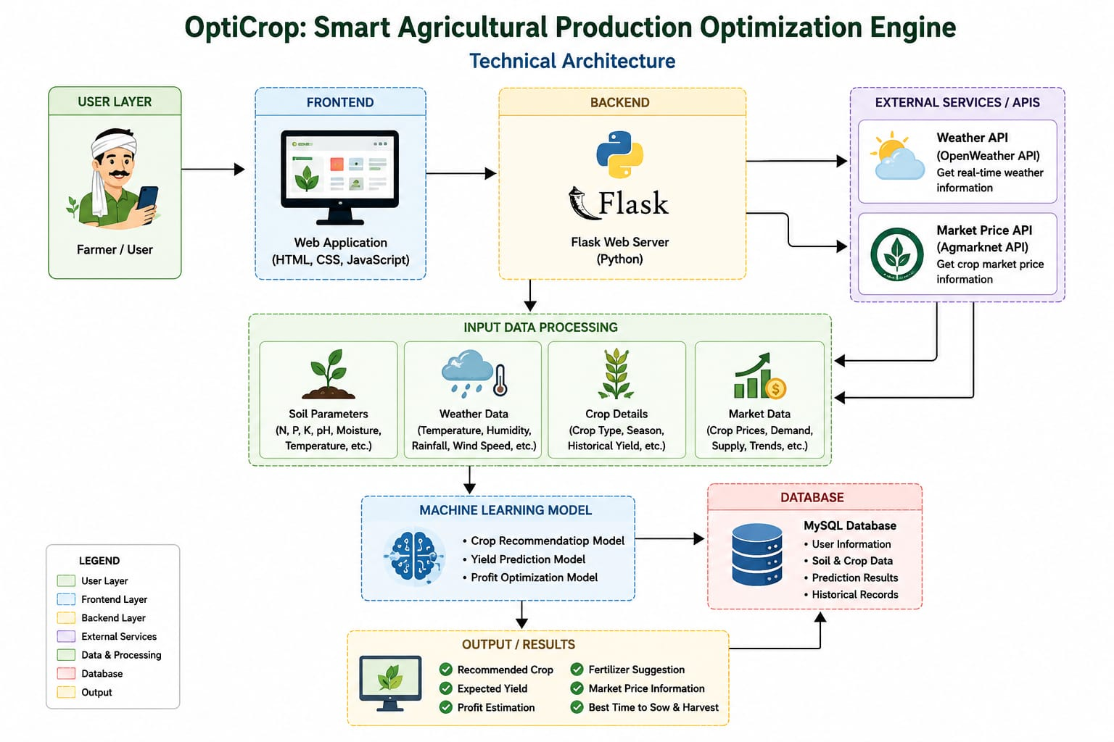
Guidelines:
Include all application processes and technology blocks.
Clearly distinguish between local system and cloud services.
Show external APIs such as the Weather API.
Indicate the database and file storage components.
Include the Machine Learning model and its interaction with the application.
Display the complete flow from user input to crop recommendation and prediction output

Table-1 : Components & Technologies:
S.No | Component | Description | Technology
 | User Interface | Farmer enters soil and weather details | HTML, CSS, JavaScript
 | Application Logic-1 | Input Validation and preprocessing | Python ,Flask
 | Application Logic-2 | Crop recommendation and optimization | Scikit-learn,pandas
 | Application Logic-3 | Result generation | Flask
 | Database | Stores farmer,crop and soil data | MySQL
 | Cloud Database | Optional cloud storage | Firebase/MongoDB Atlas
 | File Storage | Dataset and trained model | Local Storage
 | External API-1 | Weather information | OpenWeather API
 | External API-2 | Market price information | Agmarknet API(or simulated API)
 | Machine Learning Model | Crop recommendation and yield Prediction | Random Forest/XGBoost
 | Infrastructure (Server / Cloud) | Application Deployment on Local System / Cloud  Local Server Configuration:  Cloud Server Configuration : | Local PC/Render/AWS

Table-2: Application Characteristics:
S.No | Characteristics | Description | Technology
 | Open-Source Frameworks | Interactive web application | HTML, CSS, JavaScript
 | Security Implementations | User authentication and secure access | Flask Login,HTTPS
 | Scalable Architecture | Supports multiple farmers | Flask
 | Availability | Accessible anytime through web | Cloud Deployment
 | Performance | Fast crop prediction | Scikit-learn

References:
Flask Documentation
https://flask.palletsprojects.com/⁠
Scikit-learn Documentation
https://scikit-learn.org/stable/⁠
MySQL Documentation
https://dev.mysql.com/doc/⁠
Pandas Documentation
https://pandas.pydata.org/docs/⁠

